

Dear Pilgrim,

Thank you for your interest in making a pilgrimage to the Shrine of the Most Blessed Sacrament in Hanceville and to EWTN in Irondale. Although we are about sixty miles apart, we are united in our purpose of adoring our Lord Jesus Christ in the Most Blessed Sacrament and teaching the faith, in order to draw each of our pilgrims closer to Jesus. The Shrine has an emphasis on Eucharistic Spirituality. Catechesis, in order to present and preserve our faith, is the primary focus at EWTN. As you open yourself to the Holy Spirit, you will know God more fully, love Him more faithfully, and have an increased desire to serve Him more zealously.

Our Lord loves you perfectly, unconditionally, and eternally. As you make your arrangements to come here on pilgrimage, invite the Holy Spirit to guide you and to prepare your heart to commune with our Lord Jesus, Who is the King of kings and the Lord of lords. When you have responded to His call to come apart and rest awhile, in order to be refreshed and renewed in His Living Presence, He will no doubt reveal His love to you in new ways. As you empty yourself and open your soul to Him in childlike faith, He will meet you where you are, draw you to His Sacred Heart, and bless you with every spiritual blessing that you need. He will comfort you where you hurt, heal your woundedness, forgive your sins, strengthen your faith, give you a sense of purpose, encourage you in good works, and send you back into your world with the confident assurance that He will never leave you or forsake you. He will be with you always, as you share the Good News of His Truth and love with those around you. Daily He desires to renew His Covenant with you and keep His promises to you, which were sealed with His Precious Blood. His mercies are new and fresh each morning. What a faithful and loving God we are privileged to serve!

Mother Angelica, the Nuns, the Priests and Brothers, and many of us here are praying for you. God bless you, as you strive to live a holy life, pleasing to Him in a world that so desperately needs His Light, His Love, His Truth, and His Peace. We are looking forward to your coming…in God’s time.

Prayerfully,
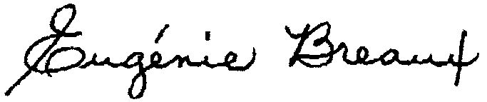

Dale Sibley, Pilgrimage Coordinator Eugenie Breaux, Pilgrimage Coordinator
Eternal Word Television Network Shrine of the Most Blessed Sacrament
(205) 271-2966 Option 1 (205) 795-5717

Planning a Group Pilgrimage

If you are planning a group pilgrimage, after reviewing this information, please contact us to confirm your desired pilgrimage date and other plans. In this way, we can ensure your group can be properly accommodated. You will also need to coordinate other details (such as lodging, transportation, activities, and meals) with our Pilgrimage Department.

In order to maintain a set schedule and to make the most of your pilgrimage to EWTN and the Shrine, we ask that any further site-seeing be planned either before or after your visit with us.

Planning an Individual Pilgrimage

The Eternal Word Television Network and the Shrine of the Most Blessed Sacrament offer several scheduled activities to visitors each day. While only groups of 10 or more may schedule extra events in advance, individual pilgrims are always welcome to join any scheduled activities. Come and spend time with our Lord!

Schedule of EWTN Activities (All times Central Time Zone)

Activities at EWTN are intended to instruct pilgrims in the Faith. Times of Catechesis are combined with times of prayer to provide a greater understanding of the ageless truths of the Catholic Church. Your trip to EWTN focuses on giving you a better knowledge of God and what He has revealed to His people so that you may stand firm and hold to the traditions taught you (2 Thes 2:15).

6:00 AM Divine Office with the Friars
7:00 AM Friars’ Conventual Mass, Televised on EWTN
8:10 AM Rosary with the Friars (8:30 AM on Sunday)
9:30 AM Catechesis* or Mass* (Monday through Saturday only)
11:00 AM Confession
11:30 AM Mass (Sundays Only)
12:00 PM Mass (Monday through Friday only)
2:30 PM Catechesis*, Healing Service*, Holy Hour *
2:30 PM EWTN Studio Tour (Monday through Friday only)
3:00 PM Divine Mercy Chaplet (Monday through Friday only)
5:05 PM Solemn Vespers and Benediction
6:00 PM Bible Study with Fr. Ray Bourque, OMI (Sundays only)
7:00 PM EWTN Live Shows (Click here to reserve Tickets) (Monday through Thursday only)

*Activities with an asterisk must be booked in advance by a group of 10 or more. Once scheduled, these activities are open to all pilgrims.

The Chapel is open from 6:00 AM to 5:30 PM for silent adoration.

Schedule of Shrine Activities (All times are Central Time Zone)

Activities at the Shrine of the Most Blessed Sacrament are intended to offer pilgrims a time of silence, prayer, and serenity. The noise of the world is drowned by the voice of the Lord, heard in the silence of prayer and adoration. Your trip to the Shrine focuses on giving you a deeper love of Jesus present in the Most Blessed Sacrament.

6:05 AM Nuns’ Divine Office
7:00 AM Nuns’ Conventual Mass
8:00 AM Confession
8:20 AM Rosary with the Nuns
9:00 AM How It all Began* for students, children and pilgrims (Monday through Friday only)
10:00 AM How It all Began* for students, children and pilgrims (Monday through Friday only)
10:30 AM Spiritual Talk * (Monday through Friday only)
11:30 AM Nuns’ Divine Office
11:50 AM Divine Mercy Chaplet with the Nuns
1:30 PM Confession (Except Fridays)
1:30 PM How It all Began* for pilgrims (Monday through Friday only)
2:30 PM Healing Service* or Spiritual Talk* (Monday through Friday only)
4:00 PM Mass in the Lower Church* (Monday through Friday only)
4:00 PM Confession (Except Fridays)
4:30 PM Nuns’ Divine Office (Sundays only)
5:00 PM Nuns’ Divine Office (Except Sundays)
5:00 PM Benediction, Televised on EWTN (Sundays only)

*Activities with an asterisk must be booked in advance by a group of 10 or more. Once scheduled, these activities are open to all pilgrims.

The Chapel is open from 6:00 AM to 6:00 PM for silent adoration.

Glossary of terms

The following terms give greater explanation to the nature of scheduled activities.

Friars’ Conventual Mass: this is the Communal Mass for the Franciscan Missionaries of the Eternal Word (MFVA), televised from the Chapel at EWTN each day.

Confessions (Sacrament of Penance) at EWTN: resident priests hear confessions at appointed times throughout the day in Saint Michael’s Hall, adjacent to the Chapel.

Solemn Vespers and Benediction in the Chapel at EWTN: recited by the Friars and followed by a Eucharistic benediction, this celebration of Evening Prayer of the Divine Office is open to everyone. By their attendance in this liturgical celebration, EWTN employees and other lay-faithful find this time of prayer is the perfect way to end the day.
First Friday Stations: immediately following Solemn Vespers, all are invited to make the Way of the Cross with the Friars.

Friars’ Divine Office: this “official prayer of the Church” is prayed publicly each day by the Friars. Through participation in the Divine Office, pilgrims have the privilege of partaking in the holiest liturgical prayer next to the Mass. Office of Readings and Morning prayer begin at 6 a.m.

Catechisis at EWTN: this hour-long talk by one of the priests or Friars focuses primarily on catechetical and spiritual subjects.

Tour of EWTN: a tour of the Network is provided at 2:30 PM Monday through Friday for pilgrim groups and all other visitors. Individual pilgrims, please notify the EWTN receptionist if you wish to take part in a tour.

Healing Service: an hour of Eucharistic adoration, including prayers for the sick, a spiritual reflection, general benediction with the Most Blessed Sacrament, followed by an individual benediction for everyone.

Holy Hour: an hour of adoration before the Most Blessed Sacrament — various prayers such as the Rosary, Novenas, and other prayers may be said and a short spiritual reflection will be given. The hour concludes with benediction with the Most Blessed Sacrament.

Bible Study in Guadalupe Hall: an intriguing time of learning the Scripture with Father Ray Bourque, OMI, lasting until 7:30 PM.

Nuns’ Conventual Mass in Upper Church: the communal Mass of the Poor Clare Nuns of Perpetual Adoration.

Confessions (Sacrament of Penance) at the Shrine: priests hear confessions at appointed times throughout the day in confessionals located at the back of the Upper Church.

Nuns’ Divine Office: this “official prayer of the Church” is chanted each day by the Nuns in their cloistered Divine Office Choir. Through silent participation in the Liturgy of the Hours, pilgrims have the privilege of partaking in the holiest liturgical prayer next to the Mass.

Spiritual Talk in Castle: an hour-long talk given by a resident priest of the Shrine or an MFVA. Focusing primarily on growth in the life of prayer and other spiritual topics, this talk is meant to feed the soul and lead the pilgrim to a deeper understanding of the beauty and demands of Christian living.

Talks by the Knights of the Holy Eucharist: informative talks about the Shrine of the Most Blessed Sacrament and “how it all began” — given to students, children, or pilgrims interested in learning more about the Lord and His Temple.

Sunday Benediction: a televised “holy half-hour of adoration” which includes singing by the Nuns, a litany or prayer, a Scripture reading, a short talk, and blessing with the Most Blessed Sacrament.

EWTN Live Shows

We welcome you to attend one or more of the various Live Shows taped at EWTN. Mother Angelica Live, Life on the Rock and The Journey Home are all taped before a live studio audience. All Live Shows begin at 7:00 PM Central Time. If you would like to be in the audience, please contact us as soon as possible. We will need your name, telephone number, zip code, show date(s), and the number of tickets you want. There is no charge for tickets, but because of the limited seating in the studio, it is wise to reserve tickets as soon as possible.

e-mail pilgrimages@ewtn.com
Telephone: 205/271-2966 option 2
Fax: 205/271-2957
Address: Eternal Word Television Network
Pilgrimage Department
5817 Old Leeds Road
Irondale, AL 35210

Lodging

Local motels offer special rates for pilgrims visiting EWTN and the Shrine. Since it takes approximately one and a half hours to travel between EWTN and the Shrine, you may wish to plan on spending the days that you visit the Shrine at accommodations in the Hanceville area, and your days visiting the Network at a motel in the Irondale area. Be sure to identify yourself as an EWTN pilgrim to receive special pilgrim rates. All prices are given minus applicable taxes. These rates are good any time except during special area events.

Lodging near EWTN

HAMPTON INN - EAST
Mileage from EWTN - 1
I-20, Exit 133
3910 Kilgore Memorial Parkway, Birmingham, AL 35210
(205) 956-4100; (800) 426-7866
Monday – Thursday: $69; Friday - Sunday only: $59

BEST WESTERN RIME GARDEN & SUITES
Mileage from EWTN - 1.3
I-20, Exit 133
5320 Beacon Dr., Birmingham, AL 35210
(205) 951-1200 ; (888) 282-1768
Standard Room $50; One bedroom suite: $60

COMFORT INN EAST
Mileage from EWTN - 2.3
I-20 at Montevallo (Exit 132-W; 132B-E)
4965 Montevallo Rd, Birmingham, AL 35210
(205) 957-0084; (800) 228-5150
Standard room: $68

RAMADA INN – AIRPORT
Mileage from EWTN - 5.6
I-59/20 at Airport Highway Exit
5216 Airport Hwy, Birmingham, AL 35212
(205) 591-7900 (800) 767-2426
Rooms: $59.00

HAMPTON INN - TRUSSVILLE
Mileage from EWTN - 7.2
I-459 at Exit 32
1940 Edward Lake Rd, Birmingham, AL 35235
(205) 655-9777; (800) 426-7866
Rooms: $63

AMERISUITES – INVERNESS
Mileage from EWTN - 8.8
I-459, Exit 19 (2.0 mi. East)
4686 Highway 280E, Birmingham, AL 35242
(205) 995-9242
Monday – Thursday: $65; Friday – Sunday: $49

KEY WEST INN & SUITES
Mileage from EWTN – 10.1
I-458, Exit 19
4400 Colonnade Pkwy, Birmingham, AL 35243
(205) 968-3700; (800) 833-0555
Sunday – Thursday: $69; Friday & Saturday: $55

BAYMONT INN & SUITES
Mileage from EWTN - 10.3
I-459, Exit 17 (1.5 mi. East)
513 Cahaba Park Cir, Birmingham, AL 35242
(205) 995-9990
Standard Room: $49; Suite: $59
Groups: Call Julia Robertson @ 256-830-8999 Ext. 119
Tour Bus Group Rates: $45 for Standard room

Lodging near the Shrine

BEST WESTERN HOTEL
I-65, Exit 310
1917 Commerce Ave., Cullman, AL 35055
(256)737-5009
Rooms: $52

COMFORT INN
I-65, Exit 310
Hwy 157, Cullman, AL 35055
(256)734-1240
Rooms: $52

DAYS INN
I-65, Exit 308
1841 4th St. SW, Cullman, AL 35055
(256)739-3800; Fax:(256)739-3123
Rooms: $41

HAMPTON INN
I-65, Exit 310
6100 Hwy 157, Cullman, AL 35057
(256)739-4444
Rooms: $65

SLEEP INN & SUITES
I-65, Exit 310
2050 Hwy 157, Cullman, AL 35057
(256)734-6166
Groups less than 25: $51; Groups of 25 or more: $49
Suites: $65

SAINT BERNARD’S CONFERENCE & HOSPITALITY CENTER
I-65, Exit 308 (Follow Ave Maria Grotto Signs)
1600 St. Bernard’s Dr, Cullman, AL 35055
(256)734-3946 (ask for Br. Andre)
Groups of 20 or more: first night $23, subsequent nights $19
Meals: with lodging – add $5; without lodging $6.50
Individuals: Lodging and 3 meals - $40 suggested donation
Individual must stay a minimum of 3 day and 2 nights

Guest Houses (near the Shrine)

Several area Guest Houses are available for pilgrims visiting the Shrine of the Most Blessed Sacrament. The houses provide a Catholic atmosphere and very good deals. The Guest Houses are listed below:

SAINT THERESE OF THE CHILD JESUS GUEST HOUSE

Mileage from the Shrine – 3.5

Intersection of County Road 747 & Hwy 91

12881 County Road 747, Hanceville, AL 35077
(256) 352-0430; Contact: Karen Williamson
4 Bedrooms, 4.5 Bath – Fully furnished kitchen & separate dining room

Individual Rooms: $65.00 includes tax
Entire House will sleep 14 people: $275.00 includes tax

SAINT MICHAEL GUEST HOUSE
Mileage from the Shrine – 1

1725 County Road 548, Hanceville, AL 35077
Toll Free (877) 778-2374; (256) 352-0271
Contact: Hale & Rhonda Wilson
Entire House: 1-4 adults: $93.50 per night (add $22.00 for each additional adult)

SAINT ANTHONY GUEST ROOM
Private Suite: Queen Bed and Sofa Sleeper
$49.50 per night

SAINT MARY GUEST HOUSE
Mileage from the Shrine – 1
1707 County Road 548, Hanceville, AL 35077
Toll Free (877) 778-2374; (256) 352-0271
Contact: Hale & Rhonda Wilson
Entire House: 1-4 adults: $93.50 per night (add $22.00 for each additional adult)

SAINT FRANCIS GUEST ROOM
Private Suite: Kitchenette, Queen and Full Beds
$60.50 per night

INN OF SAINT CATHERINE
Mileage from the Shrine – 1
1221 County Road 548

Hanceville, AL 35077
(256) 709-2985 Judy Warwick or (256) 708-1713 Barbara Dunn

Entire House: 7-8 adults: $150.00 per night
1 Adult: $55.00 per night
2-4 Adults: $65.00 per night

**No Charge For Children**

Essentials

Dress and Decorum: In order to show respect to our Lord Jesus Christ, truly present in the most Blessed Sacrament, as well as to show a spirit of charity to the Nuns, the Priests and Brothers, and the other pilgrims, we request the following:
+Please observe silence when you enter the Shrine and the EWTN Chapel.
+We encourage you to dress comfortably, but modestly. Please do not wear sleeveless tops, tank tops, shorts, or mini-skirts. Ladies may wear slacks.
+Please do not leave Mass before the Blessed Sacrament has been exposed and the Nuns have finished singing at the Shrine.
+Please do not take pictures inside the Shrine. There are many lovely pictures and postcards you may purchase at the Gift Shop in Castle San Miguel. At all other locations, pictures are permitted.

Gift Shops: The gift shops serve as the main means of financial support for the nuns. Each has a unique selection of beautiful statues, crucifixes, rosaries, books, videos, and many other “holy reminders” to nurture your faith. The Shrine’s gift shop is open Monday through Saturday, 8AM to 5PM . The EWTN gift shop is open 8AM to 4PM Monday through Friday and 8AM to 3PM on Saturday. Be sure to visit both!

Shuttles: Some motels in the EWTN area have shuttle service to EWTN and to the Birmingham International Airport. On Monday through Thursday, The Best Western Rime Garden Inn and Suites also has a round-trip shuttle between Irondale and the Shrine. There is, however, no shuttle service from the Cullman motels to the Shrine.

Transportation: If you prefer not to drive to Alabama, you may fly into the Birmingham International Airport, come on the Amtrak train, or use the Greyhound Bus service. You will need to set up your own transportation from these terminals. Thrifty Car Rental offers special deals for EWTN pilgrims. Advance reservations are strongly recommended and may be booked by calling 1-800-255-2216 ext. 200 or my e-mailing reservations@gothrifty.net. Be sure to ask for the special EWTN Pilgrimage rate.

Meals: No food services are available on the grounds of EWTN or the Shrine. Picnic tables, vending machines and indoor facilities are available for those individuals who wish to bring a picnic lunch. Also, groups may have catered meals delivered to the Shrine or EWTN. Each group leader is responsible for making arrangements. A list of caterers is included for your convenience.

Caterers near EWTN (for groups only):

Mr. A’s Eatery and Market
2832 Crestwood Blvd, Irondale, AL 35210
(205) 951-5545
Breakfast, Lunch & Dinner (Hot or Cold)

Domino’s Pizza
1506 Montclair Road, Birmingham, AL 35210
(205) 956-8300
Lunch & Dinner
*10 or more Pizzas: Large, 1-topping for $7.00 each

Subway Sandwiches & Salads
5415 Beacon Dr., Irondale, AL 35210
(205) 951-2522 (Fax is same #)

Lunch Box Express
1719 27th Terr. So., Homewood, AL 35209
(205) 871-7901; Cell # (205) 585-7577
24-hour notice required; can make children’s sack lunches

Klingler’s European Bakery & Cafe
621 Montgomery Hwy, Vestavia Hills, AL 35216
(205) 823-4560; FAX 823-5563
Lunch & Dinner (Hot or Cold)

Caterers near the Shrine (for groups only):

Seven Winds Kitchen (Jane Gammon)

Phone: 256-734-0246
Fax: 205-556-0036
Breakfast; Box Lunches

Contact Us

If you have any questions about pilgrimages, please contact our Pilgrimage Department:
Email: pilgrimages@ewtn.com
Telephone: 205/271-2966 option 1
Address: Eternal Word Television Network
Pilgrimage Department
5817 Old Leeds Road
Irondale, AL 35210

Fax: 205/271-2957

Map and Details to EWTN
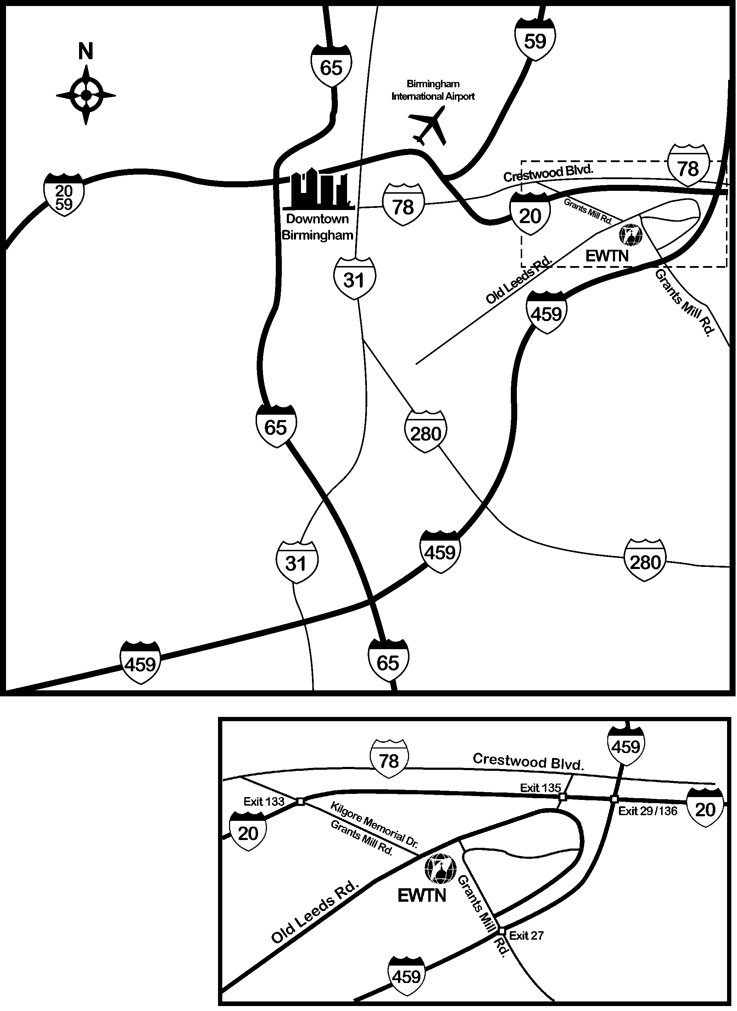

EWTN
5817 Old Leeds Road
Irondale, Alabama 35210
205/271-2900

EWTN is located about 1.5 miles from the intersection of I-20 and Kilgore Memorial Dr. Going either direction on I-20, take Exit 133 and go South (if exiting from I-20 East: turn right; if exiting from I-20 West: turn left off the exit ramp, then left again at the first traffic signal). Go up the hill until you come to a stop sign (the road dead ends here) and turn left onto Old Leeds Road. EWTN is about 100 feet on your right.

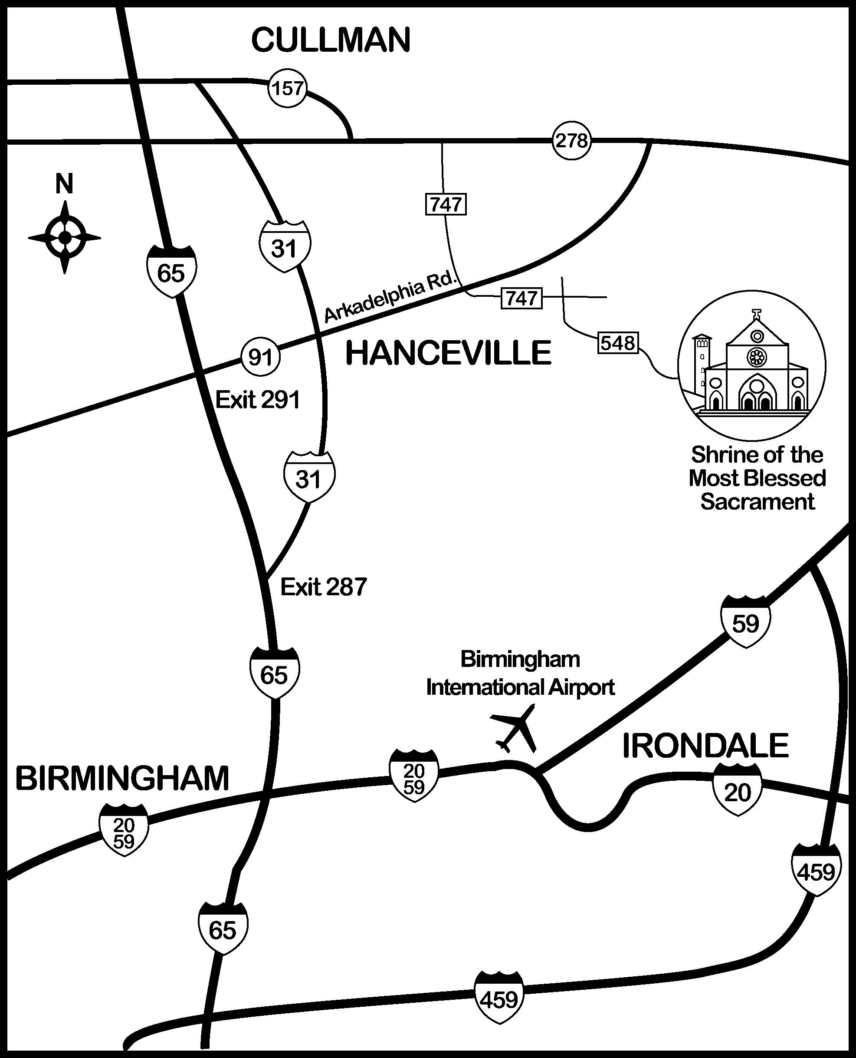
Map and Details to the Shrine

The Shrine is located about 6 miles from the intersection of Hwy. 91 and Hwy. 31 in Hanceville, Alabama. Going either direction on I-65, take Exit 291 for Hwy. 91 North. Turn right at County Road 747 and right again at County Road 548.

Shrine of the Most Blessed Sacrament
3224 County Road 548
Hanceville, Alabama 35007
256/352-6267

